# Lab: HTTP BASICS

Problems for in-class lab for the [“Programming Fundamentals” course @ SoftUni](https://softuni.bg/modules/57/tech-module-4-0).

## Installing Needed Software

## Postman

You can download Postman from [here](https://www.getpostman.com/apps).

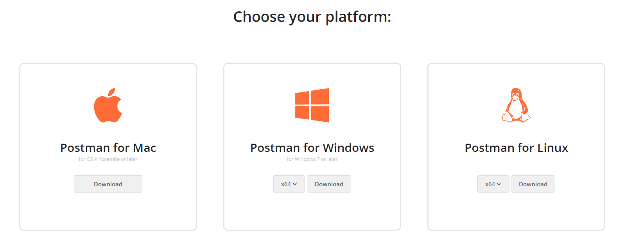

1. **Make Basic HTTP Requests**
2. **Kinvey: Handshake**

Kinvey is a **Mobile Back-End** as a Service (mBaaS).

To fulfill a **handshake,** we have to enter the following "**GET**" request in **Postman**:  
<https://baas.kinvey.com/appdata/kid_S1rDXLP4N>

Firstly, go to **Authorization** in **Postman** and select "**Basic Auth**". And enter **username**: "guest" and **password**: "guest":

**Request**:

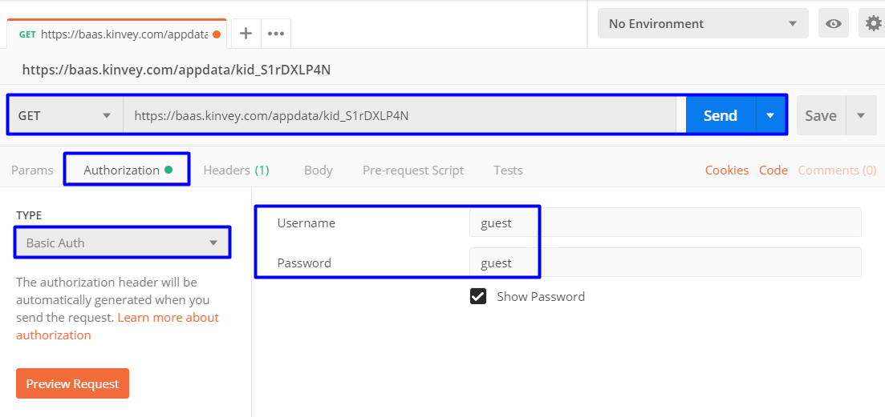

**Response**:

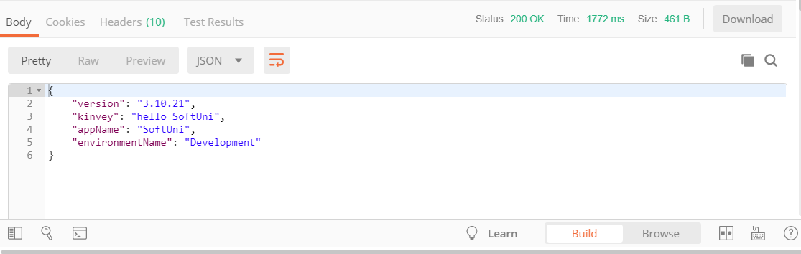

1. **Get All Songs**

Go to **Authorization** in **Postman** and select "**Basic Auth**". And enter **username**: "guest" and **password**: "guest".

After that **listing** all songs should be easy **with** the following request:  
<https://baas.kinvey.com/appdata/kid_S1rDXLP4N/songs>

**Request**:

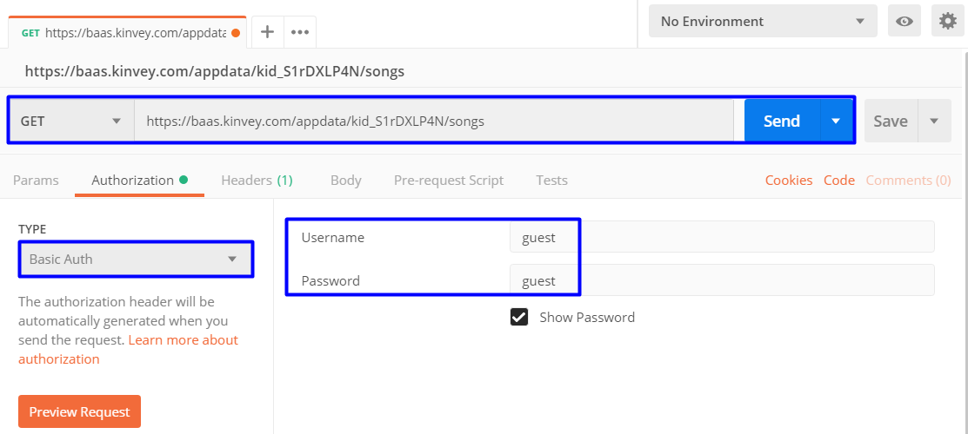

**Response**:

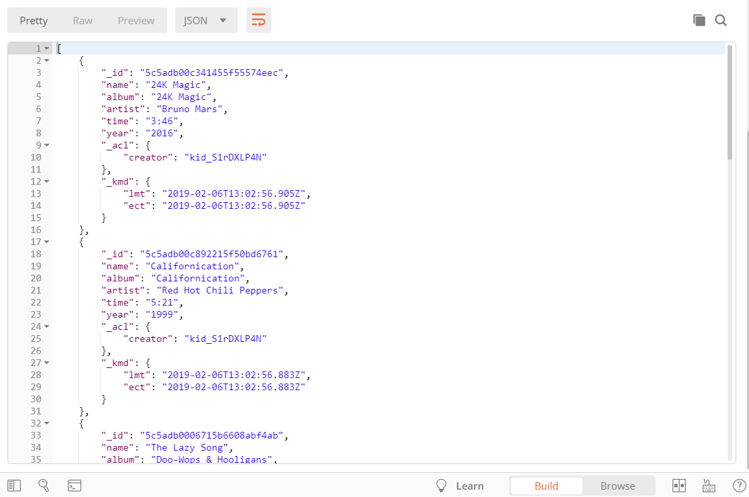

1. **Create New Song**

Again, go to **Authorization** in **Postman** and select "**Basic Auth**". And enter **username**: "guest" and **password**: "guest" Now we should create a **new** song:

**Request**:

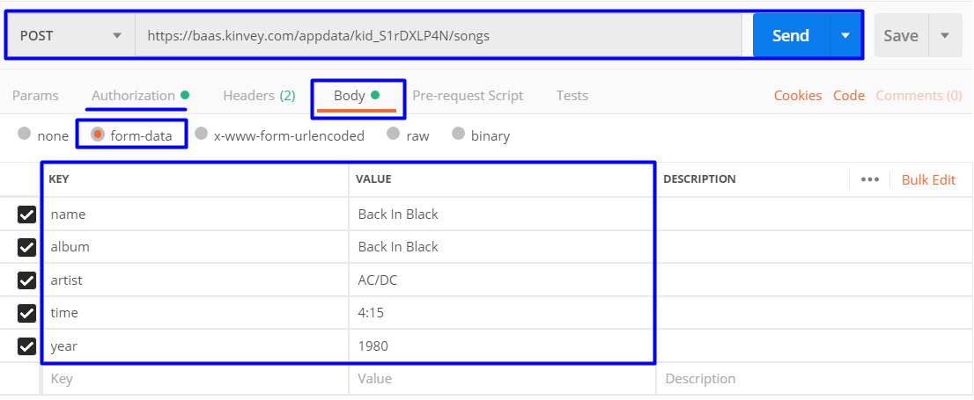

**Response**:

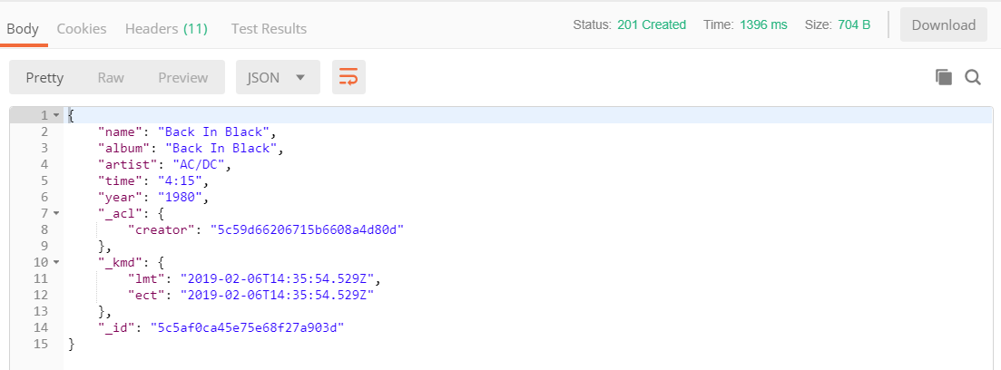

1. **Delete a Song**

Now let us **delete** the **newly** created song.

**REQUEST "DELETE":** <https://baas.kinvey.com/appdata/kid_S1rDXLP4N/songs/postId>. The **postId** can be found from the JSON response of the **previous** task:

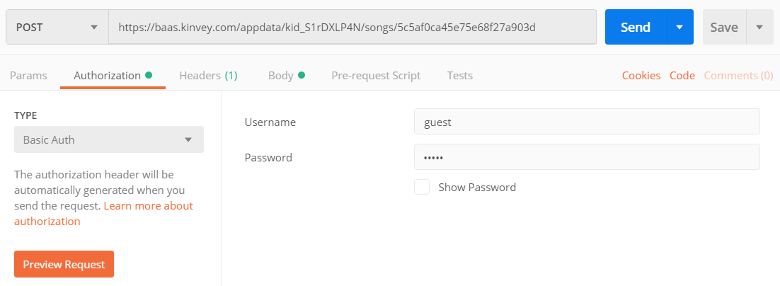

The "**DELETE**" request should **generate** a response that tells us how **many** posts we have **deleted**:

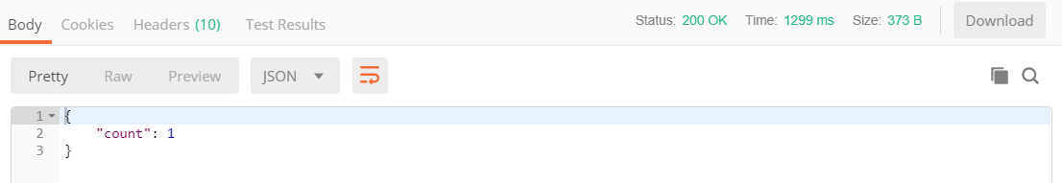

Now, when we get all songs we can notice that the song **"Back In Black"** is not in the list.

1. **Edit a Song**

Edit a Song with a "**PUT**" request. <https://baas.kinvey.com/appdata/kid_S1rDXLP4N/songs/5c5adb00c892215f50bd6761>

**Change** the following columns:

* **name**: "Dani California"
* **album**: "Stadium Arcadium"
* **time**: "4:43"
* **year**: "2006"
* add an additional column: **genre**: "Rock"

**Request**:

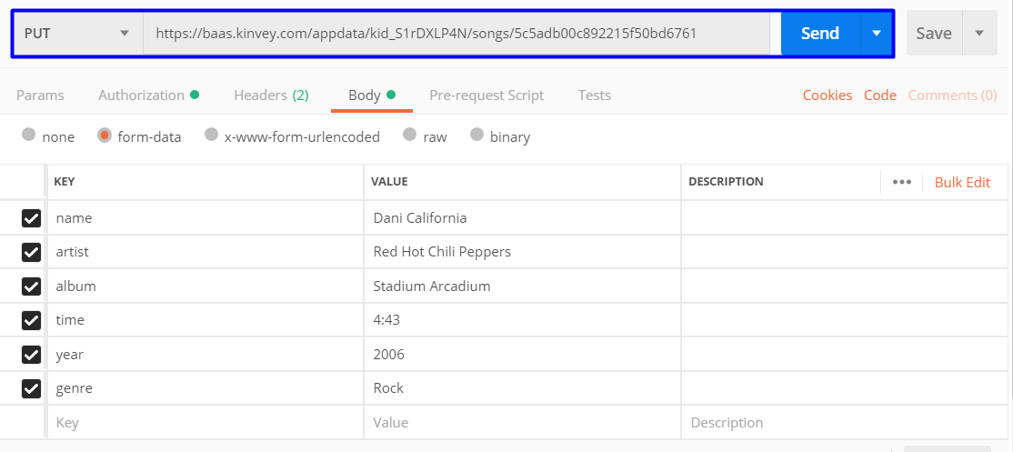

**Response**:

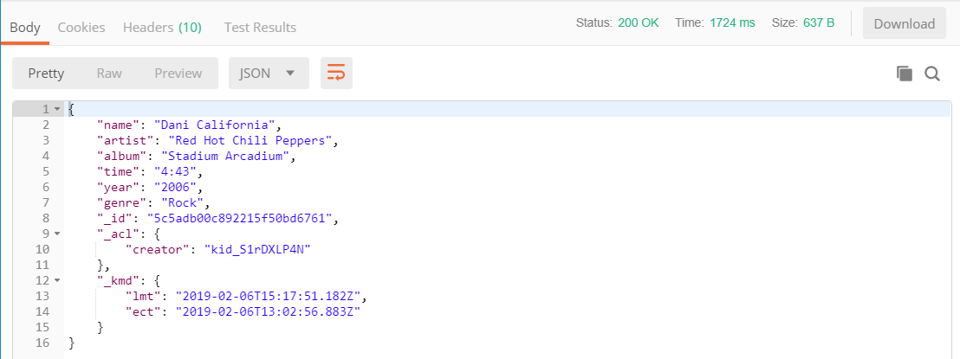

1. **Login**

Again, go to **Authorization** in **Postman** and select "**Basic Auth**". And enter **username**: "guest" and **password**: "guest"

**Logging** in is done with a "**POST**" request with the **following** url:   
<https://baas.kinvey.com/user/kid_S1rDXLP4N/login>

You should also send your **credentials** through the JSON **body**:

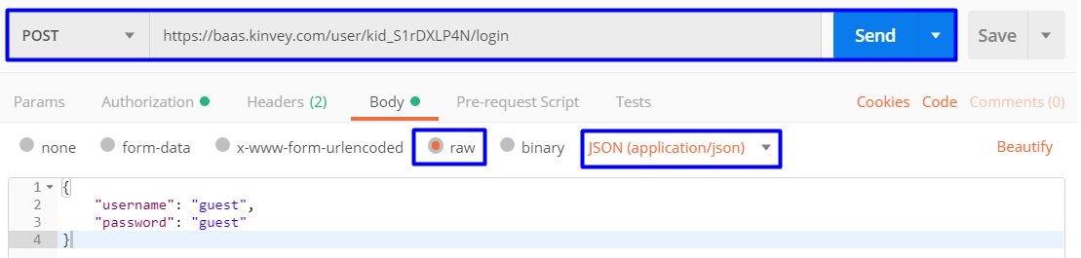

After a **successful** login you should **receive** the following **response**:

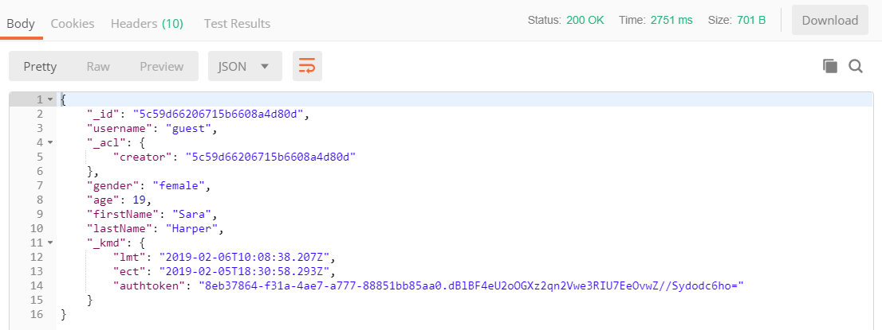

Save the **authtoken**, because you will **need** it for the **final** task.

1. **\*Bonus: Logout**

Lastly we have to **logout** from the application. Change the **Authorization** to "**No Auth**". To do so we have to send a "**POST**" request with the **following** url: <https://baas.kinvey.com/user/kid_S1rDXLP4N/_logout>

Remember that long **authorization** token ? Now we have to copy it and paste it in the **Postman "Headers"** section:

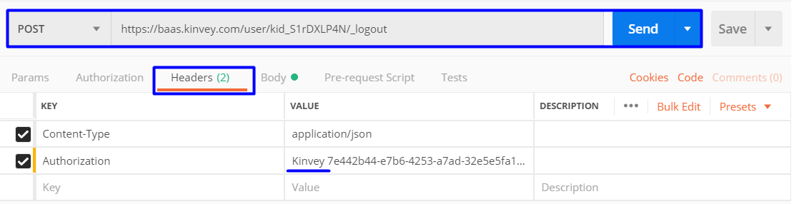

After you click "**Send**" the response body **should** be **empty**. Doing it **again** should trigger an **error**.

